**Full Stack Development with MERN**

**Project Documentation format**

**1. Introduction**

* **Project Title:** ShopEZ: E-Commerce Application
* **Team Members:**

1)Mokshagna Vuppala- Team Leder

2)Dwijesh Reddy– planning of the project

3)R. Nikhlesh – Frontend Development

4) Maguluri Subhash Sranath -Backend Development

**2. Project Overview**

* **Purpose:** ShopEZ aims to be a user-friendly e-commerce platform allowing customers to browse, select, and purchase products online.
* **Features:** Secure user registration and login for account creation and access, and Order confirmation, tracking, and account-related order history.

**3. Architecture**

**Frontend:**

• ShopEZ utilizes React, a popular JavaScript library, to build a user-friendly and interactive front-end experience.

• React's component-based architecture allows for modular development of UI elements like registration forms, product listings, and potentially a future shopping cart interface.

• The front-end likely interacts with the backend API using techniques like fetch to make requests for user data, product information, and functionalities like adding items to a cart.

**Backend:**

•The ShopEZ backend leverages Node.js, a JavaScript runtime environment, to execute server-side logic and handle API requests.

• Express.js, a popular Node.js framework, likely provides the foundation for building the API endpoints responsible for user registration, login, product data retrieval, and order processing.

• User credentials and product data are likely stored securely in a database (e.g., MongoDB) with appropriate access control mechanisms implemented within the Node.js backend.

**Database:**

• MongoDB, a NoSQL document database, is a potential choice for storing ShopEZ's data due to its flexibility and scalability.

• The database schema would likely consist of two main collections:

* Users: Stores user information like email addresses, hashed passwords, and potentially additional user details.
* Products: Stores product information like names, descriptions, prices, images and category information.

**4. Setup Instructions**

* **Prerequisites:** ShopEZ's backend relies on Node.js for server-side execution and npm as the package manager for installing dependencies and the project likely utilizes MongoDB as the NoSQL database for storing user and product data.
* **Installation:** Clone & Navigate:
* Clone the ShopEZ repository using Git
* Git clone https://github.com/mokshagna-vuppala/ShopEZ-E-Commerce-Application
* Navigate to the project directory: cd shop-ez
* Install all required project dependencies/node modules: npm install

**5. Folder Structure**

* **Frontend:** contains app.js,components,pages.
* **Backend:** contains index.js,schema.js.

**6. Running the Application**

* Provide commands to start the frontend and backend servers locally.
  + **Frontend:** npm start in the client directory.
  + **Backend:** node index.js in the server directory.

**7. API Documentation**

* Document all endpoints exposed by the backend.
* Include request methods, parameters, and example responses.

**8. Authentication**

* non

**9. User Interface**

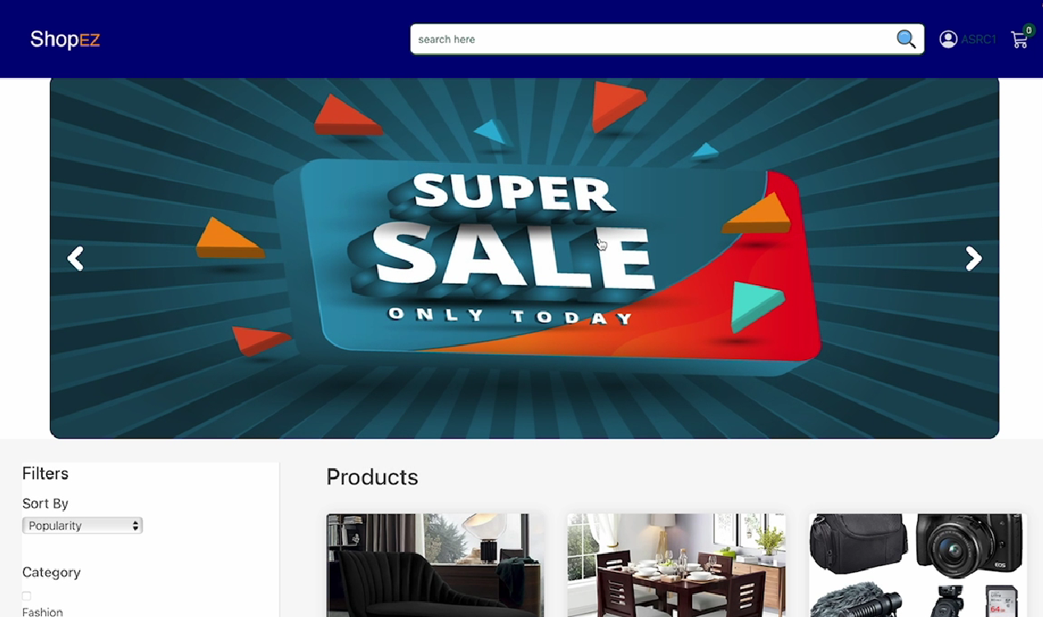

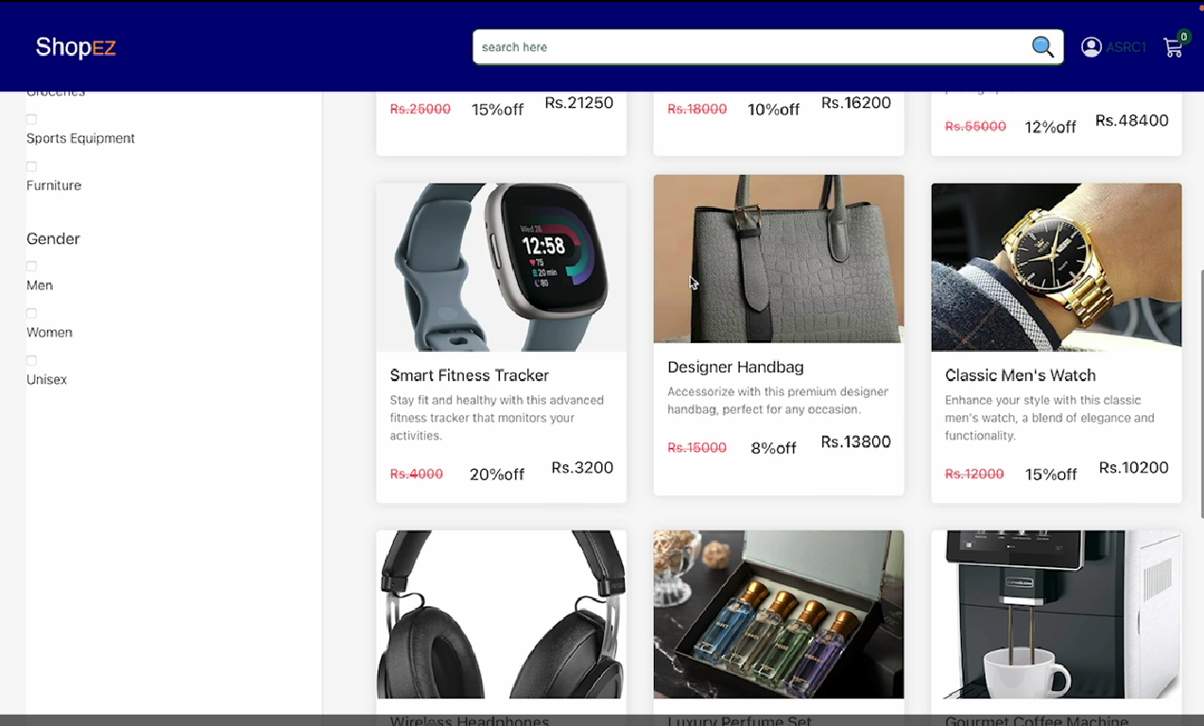

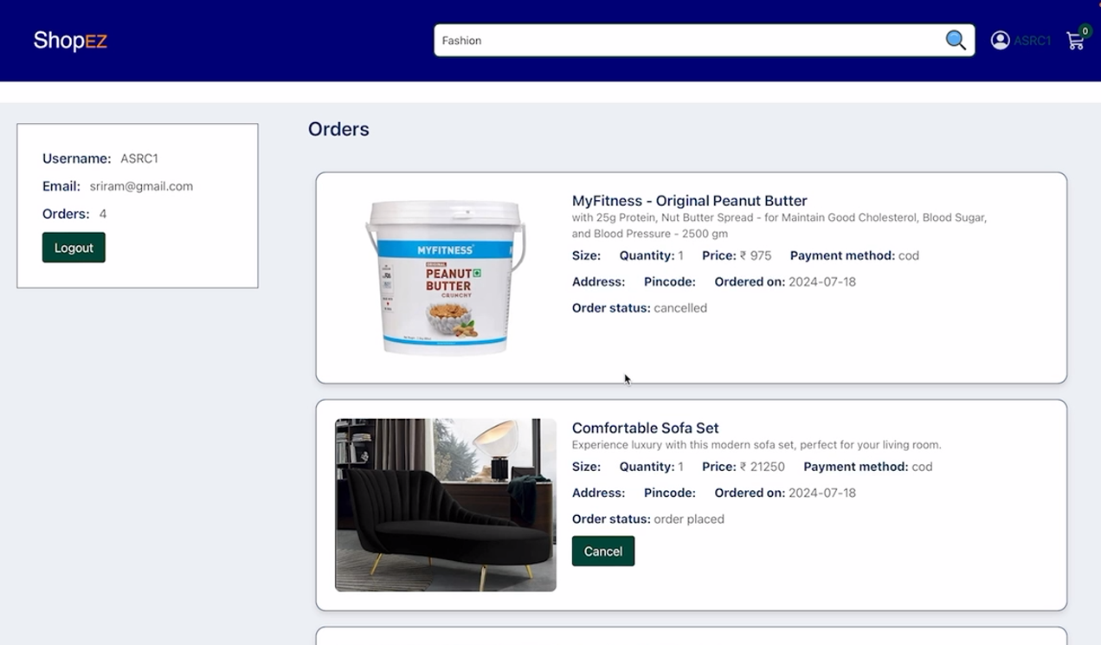

**10. Testing**

* explore various parts of website and check for updates.

**11. Screenshots or Demo**

* Provide screenshots or a link to a demo (if available) to showcase the application.

**12. Known Issues**

* non

**13. Future Enhancements**

* Can be made more interactive and quicker